Template for Evidence(s)
UI GreenMetric Questionnaire

University : ...
Country : ...
Web Address : …

[7] Governance and Digitalization (GD)
SAMPLE

[7.8] Financial Report (GD.4)

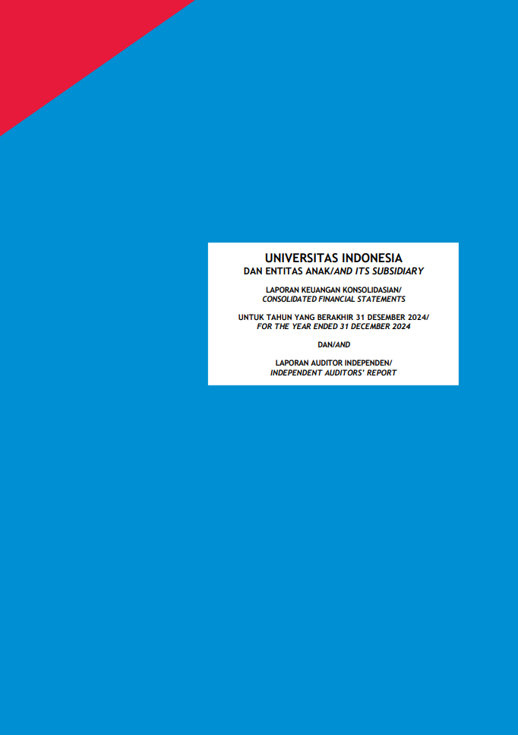
Examples of sustainability report (Universitas Indonesia, Indonesia)

Description:
(The following is an example of the report link/url)
Annual regularity should be proven at least for the last 3 years

Additional evidence link (i.e., for videos, more images, or other files that are not included in this file):

Example: https://ppid.ui.ac.id/laporan-keuangan-universitas-indonesia/

